My Money .... Maths Ideas for Home
At Parkfield Community School we understand how important it is that children learn to understand money and what it means as well as how to look after it. Learning about money and how to make decisions about money is called ‘Financial Capability’. Throughout the year during maths and PSHE lessons children are learning to be financially capable. We ask that you support us with this through enjoying some simple activities at home with your children. Take a look at the ideas here and try them. You may have some ideas of your own – I’d love to hear them. Many thanks for your support.
Mrs Hackett
Children in foundation stage (nursery/reception)
Coin recognition.
Put a jar of mixed coins and buttons on a table, along with a selection of everyday items you might buy in a shop that are for sale, each with a different price eg: an apple, book, pencil, teddy bear.
Can your child look through the jar and sort the coins from the ones that are not money?
Which is the biggest coin?
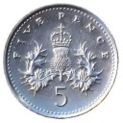
Which is the smallest?
Can they see any numbers on the coins?
Can they put all the 1p coins together? Then all the 2p coins and so on?
Can they find one of each coin?
Can they put the coins in order of size, then re-order them in order of value?
Can they find the correct coins to buy each of the items priced?
How do they make 3p? How do they make 5p? How many different ways can they make 6p?
Can they find different ways of making other amounts, such as 8p?
Which item is the most expensive? Which is the cheapest?
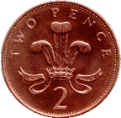
Children in reception and KS1
Books
Provide a selection of picture books which have financial themes and read with your child. Talk about the financial issues in the book.
Some examples:
Charlie and Lola – Please May I Have Some More of Yours? By Lauren Child.
Charlie and Lola have a day out at the zoo. Lola is keen to buy a toy seal for her bath but she can’t seem to save her pocket money. Charlie lends her some money and Lola eventually gets the hang of saving.
Dogger by Shirley Hughes.
Dave loses his beloved toy Dogger, which eventually turns up on a stall at the school fete. A little girl guys Dogger before Dave can raise the money to buy him back.
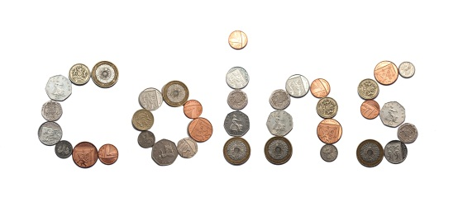
Other books:
The Great Pet Sale by Mick Inkpen
Little Croc’s Purse by Lizzie Finlay
A Chair for my Mother by Vera B Williams
A Bargain for Frances by Russell Hoban
One Hen: How One Small Loan Made a Big Difference on the Day by Kate Smith
The Gold Coin by Alma Flor Ada and Neil Waldman
Tight Times by Barbara Shook Hazen
The Berenstain Bear’s Trouble with Money by Jan and Stan Berenstain
How Much Is A Million? By David Swartz
A Bargain For Frances by Russell Hoban. HarperCollins, 1970. Age 5 and up. Frances saves and saves
for a china tea set. Her friend Thelma tricks her into buying an old plastic tea set. Thelma says there are no “backsies” on the bargain. Frances finds a way to get what she really wants.
A Chair For My Mother by Vera B. Williams. Greenwillow Books, 1982. Age 6 and up. A family loses all their furniture in a fire. They set a goal to buy a chair for mother. Find out how the family, neighbours and friends work together for success.
All The Money In The World by Bill Brittain. HarperCollins, 1979. Age 9 and up. A young boy’s wish for all the money in the world comes true. The boy finds out that having all the money in the world isn't as fun as he thought.
The Money Tree by Sarah Stewart.
Sam and the Lucky Money by Karen Chinn

Children in KS1 and KS2

Show children a range of objects or discuss objects. Explore the difference between ‘need’ and ‘want’.
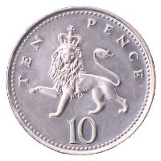
I need new shoes.
I need a computer game.
I need a packet of crisps.
I need a mobile phone.
(Which is a real ‘need’ and which are ‘wants’?)

Cost of running a home

Get children to draw a simple outline of a house with some rooms inside. Work with your child to write around outside the house all the things in a house that cost money, such as electricity, food, water, furniture, pets, etc. This can be extended for older children to include outside the house, such as street lights, rubbish collection, etc.
Discuss where the money comes from to pay for all these things and how it is earned. Talk about why people pay tax and how it is used.

The Best Offer

Encourage children to study special offers in the supermarket and adverts in magazines.
Offers such as:
3 for the price of 2 or buy 2, get one free? - Is it cheaper to buy one large bottle or two smaller bottles? - What will the price be with 20% off?
Discuss the offers; be careful to check labels for weights, contents, capacity when making comparisons. Which is the best offer and why?

