Parkfield Community School
Child Friendly Safeguarding Policy
What is safeguarding?
It is everybody looking after your health, safety and welfare: keeping you safe.

How do we safeguard you at Parkfield?
- We know what our roles and responsibilities are to keep you safe.

- We take all concerns seriously and report them properly.

- We talk to other people about any concerns to try to find the best way to help you and your family.

- We check out anything that might be dangerous to you in school, or during activities out of school and make a plan to make these less dangerous.

- We have assemblies, lessons and awareness weeks where we learn about safeguarding such as privacy, safe touch, e-safety and anti-bullying.

- We treat everyone fairly with dignity and respect.
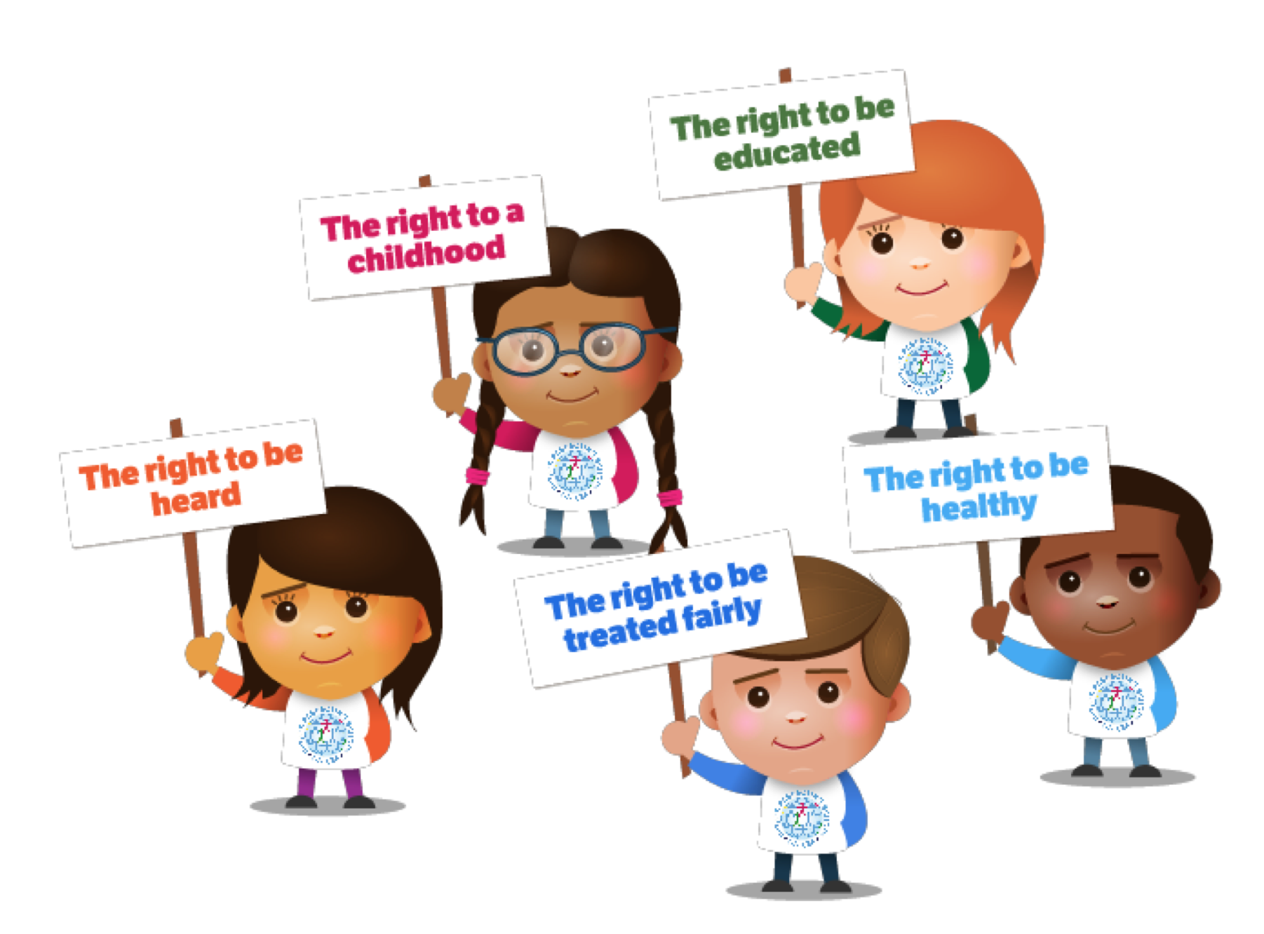
What do you need to understand about safeguarding?
You have:
- All adults will listen to what you have to say.

- Adults may ask you questions. If they are
worried about your safety, they might ask
someone else to talk to you.

- Adults will never stop you from freely
talking about significant events.

- Adults will write down what you say to make
sure that we do not miss any information.

- Adults will not promise to keep secrets. They will explain that they have a responsibility to report what has been said to someone else if they are worried about your safety or the safety of somebody else.

- All adults will immediately tell the Safeguarding Team if they are worried about your safety or the safety of somebody else.
Our Safeguarding Team
Mrs Susarla  Lead DSL & AHT | Mr Wright  Deputy DSL & Head Teacher | Mrs Brzeski  Deputy DSL & Deputy Head | Mr Arshad  Deputy DSL & SENDCO | Mrs Gordon  Deputy DSL & AHT
Mr Lewis  Deputy DSL & AHT | 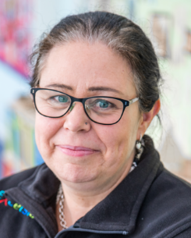  Mrs Vaughan DSO & Office Manager | Mrs Ali  DSO & Learning Mentor | 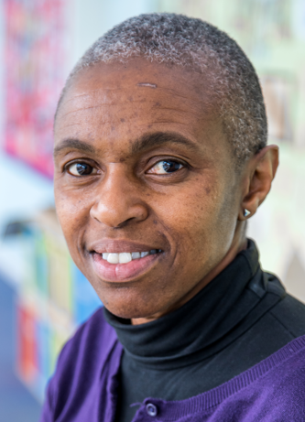  Miss Smith  DSO & Learning Mentor | Mrs Kamran  DSO & Attendance Officer

What should you do if you need to speak to somebody?
Speak to an adult at school if you are worried about something, it could be your teacher, a teaching assistant or a dinnertime supervisor.
Childline is a free to call and confidential service where you can talk about anything that is worrying you.

