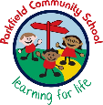

Year 1 Newsletter
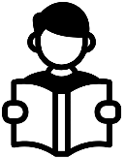
Autumn Term- September 2026
Homework
Every child will bring home a school, reading book. These books are linked to the RWI lessons your child attends daily. Please be sure to look after these books and bring them to school daily. Books will be changed on a Friday weekly. Children should be reading every day at home, ideally with an adult who can help them with the tricky words and ask them questions about what they have read. Reading diaries should be brought into school every day. We ask parents to sign the reading diary every evening after you have heard your child read.

Important things to remember:
Miss Johns 1J
Mrs Bather 1B
Miss Maryeam 1M
Mrs Drysdale/Mrs Cornforth
Miss Naz
Miss Malik
What we are learning this term:
Our PE day is Tuesday. Your child should come to school in their PE kit every Tuesday. A Parkfield PE kit consists of a white top and black trousers with trainers or pumps.

Dear Parents/Carers,
We welcome you and your child to Year 1 and we hope that you had a restful break. This newsletter contains information about Year 1 and your child’s learning . If you have any questions, we are here to help.

A message from your child’s teachers:
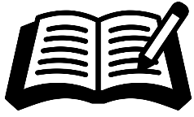
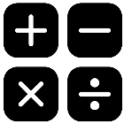
In Year 1, phonic lessons are very important. You can help your child at home by practising the sounds that they have focused on in the week. New sounds are published online via our weekly, school newsletter. We will send further information regarding the phonics, screening test later on in the year.

- To write using the
correct letter formation.
-To use capital letters and full stops consistently, and other punctuation such as question marks.
-To retell and write
stories with a beginning, middle and end.
- To use the conjunctions:
And to join sentences together.
- To sound out words using their phonic knowledge.

- Exploring numbers to 10.
-Addition and subtraction.
-Geometry- position and direction.
-Number and place value to 20.
-Exploring the relationships between part and whole.
-Number bonds and facts to 10.
-Counting forwards and backwards to 10.

Phonicsw
Writing
Maths
Staff:
Homework:


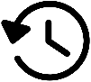

Geography:
History:
Science:
This term we are focusing on geography and developing our geography skills. As we move into the spring term, we will explore the four nations and the local area.
We will be learning about two significant artists- Van Gogh and L S Lowry. The children will have the opportunity to learn about history and produce their own art work linked to these significant figures.

This half term we will learn about everyday materials.

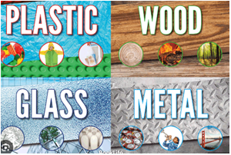


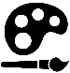

In RE, we will be looking at community, births and naming rituals.
RE:
Art:
DT:
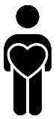

Oracy:
Personal Development:
In PD, we will be exploring ‘Health and well-being’. We will be learning about how to keep our bodies clean and health and safety in the home. We will also explore our sense of belonging.

Oracy is a key focus in Year 1 and we use and develop our oracy skills in every lesson each day. We will continue to practise speaking in clear sentences which build on one another’s ideas. We practise taking turns with our talk partner and we begin to ask questions to develop our understanding further.
.

We will explore our art and design skills through the use of spirals.

As part of our DT lessons, we will be exploring sliders and leavers.

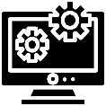


As a part of our computing lessons, we will be exploring developing mouse skills, keyboard skills and using a computer responsibly.

We look forward to working together with you this term!
Computing:
Music:
PE:
Music this term will focus on the theme ‘Hey You’.
In PE, Year 1 will focus on fundamentals, gymnastics, team building and ball skills.

