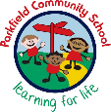

Year 3 Newsletter
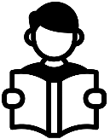
Spring Term- January 2026
Reading
What we are learning this term:
Our PE day is Monday. Your child should come to school in the correct PE kit every Monday.

Children in 3K will be attending swimming lessons every Tuesday throughout the Spring term. (This will commence until Tuesday 24th March 2026)

This term, we will be conducting a reading workshop to inform parents and carers on how best to support the children with their reading at home.

Important things to remember:
Homework
Spellings – Lists will be given out on Monday, to be tested on the following Monday.
Mathletics – children will be expected to earn 1000 points a week on Mathletics. They should log on for around 30 minutes, three times a week.
Reading – children should be reading everyday, ideally with an adult who can help them with tricky words and ask them questions about what they have read.

Your child will continue to receive homework, every Friday, to help and further develop what they are learning in class.

Mrs Fagan 3F
Mrs Khan/Miss Rage 3K
Miss Bano 3B
Mrs Hussain

A message from your child’s teachers:
A warm welcome back to all our Year 3 parents and carers. We hope you all had a lovely break. We look forward to another term as we continue to work with you and your children. If you have any questions please contact the school office or your child’s class teacher at home time.

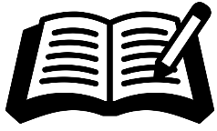
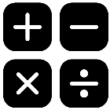
In Year 3, reading lessons are very important. You can help your child at home by listening to them read every day and asking questions to show that they have understood what they have read.
This term they will be studying the novel Max and the Millions by Ross Montgomery.

-This term the children will be writing a suspense narrative based off the novel The Wolves in the Wall by Neil Gaiman.
-The children will also be writing a Non-Chronological report about a chosen animal.
-The children will be expected to form all letters correctly and use neatly, joined handwriting.

Writing
- Writing length in metres, centimetres and millimetres.
- Comparing lengths.
- Reading weighing scales.
- Measuring volume and capacity in millilitres and litres.
- Counting, showing amounts, adding and subtracting of money
- Calculating change
- Telling the time, measuring and comparing time in seconds, minutes and hours. and hours., converting minutes to seconds, seconds to minutes
- Finding number of days

Maths
Staff:
Homework:



Geography:
History:
Science:

Geography is the study of places, people and their environments.
This term in geography we will be learning about The UK.

History is the study of the past.
This term in history we will be learning about The Roman invasion of Britain.

Science is the process of learning about the natural world through observation and experimentation.
This term we will learn about light and materials.


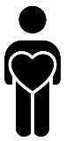






Our oracy targets this term are to show an awareness of audience through the correct choice of formal/informal language.
To take part in a consensus circle and reach a shared conclusion.
Also, to deliver a short presentation (with notes) to an unfamiliar audience .

.

Oracy:

In Our PD lessons this term, we will be thinking about our Talents, Interests and Abilities. We will also be looking at Faith and Belief in the UK and Living Together .
Personal Development:
Computing:

In computing, we are going to be learning about how computers are connected.
In music this term, the children will be developing their notation skills and learning about how music brings us closer together.
Music:

In PE, we will be focussing on Ball skills, Outdoor Adventurous Activities and swimming.
PE:

This term in RE we are learning about Christianity.
RE:

In art, we will be creating a piece of art using cloth, thread and paint.
Art:

This term in the STEM lab, we will be designing and making a product using materials.
DT:
We look forward to working together with you this term!

