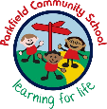
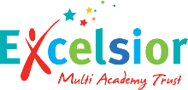
Year 5 Newsletter
Autumn Term- September 2026
We’re excited to welcome you and your child to the new school year. We hope you had a relaxing break. This newsletter will give you important information about Year 5 and what your child will be learning. If you have any questions, please don’t hesitate to ask—we’re here to help.
A message from your child’s teachers:
Reading – Every child will bring home a school reading book. Children should be reading every day at home, ideally with an adult who can help them with the tricky words and ask them questions about what they have read. They should also complete their reading diary. MAGMA – children will be expected to practice a wide range of Maths skills – this will be set by their Class Teacher across the year. Times Table Rock Stars - children are expected to practice their multiplication at home frequently and be fluent with all their times tables. Spellings – new spellings will be handed out each Monday, with the test being the following Monday. Your child may have different spellings to other children – teachers have carefully considered what is best for your child and these should be practiced at home.

5SD:
Mr D. Dowson (Assistant Headteacher) & Mrs S. Sheikh
5A:
Mrs S. Ahmed
5W:
Mr J. Vale & Mrs C. Walsh
TA: Mrs A. Harris
Maths
What we are learning this term:
Staff:
Homework:

Important things to remember:
Please ensure that your child comes to school every day with their own water bottle, clearly labelled with their name and class. The children are also expected to wear the correct uniform. This includes a white shirt or polo shirt, the school tie which has been provided and grey or black trousers, skirt or a dress (or a summer dress during the warmer months). Our PE day is MONDAY. Your child should come to school in their PE kit every Monday.
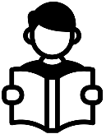
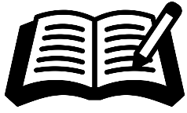
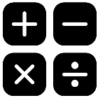

- Rumaysa Fairytale, ‘One Small Step’, NASA Persuasive Leaflet.
- To write a fairytale using speech and dialogue
- To enhance descriptions by using Similes, metaphors and personification.
- To write a persuasive leaflet using parenthesis and relative clauses.
- To begin to accurately spell words from the Y5/6 spelling list

Writing
Reading
This term, we will be looking at fairytales and non-fiction extracts. We will particularly be focussing on:
Define: Children learn to understand and explain the meaning of words and phrases in context.
Retrieval: Children practise finding specific information directly from the text, such as facts or details.
Inference: This skill helps children read between the lines—using clues in the text to understand what’s not directly said.

- Read, write and compare numbers to 1000 000
- Rounding to nearest 10, 100, 1000, 10000 and 100000
- Adding and subtracting within 1000 000
- Finding prime, squared and cubed numbers
- Multiplying and dividing by 10, 100 and 1000
- Multiplying 2 and 3 digit numbers by 2 digit numbers.
- Solve a range of calculation problems


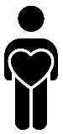

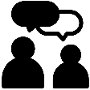



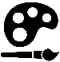
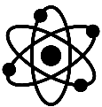
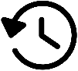
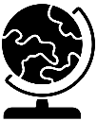
We look forward to working together with you this term!
Oracy:
Personal Development:

In Our PD lessons this term, we will be learning about relationships. We will be looking at how to share our feelings, how it feels to be segregated, and understand how our mental health can affect our friendships.

Our oracy targets this term are to use gestures effectively to persuade an audience. Also, we will be working with Mrs Andrews (our Digital Media Ambassador) to create a digital debate.
This term in RE we are learning about Islam. After half term, we will also be visiting the Birmingham Central Mosque.
RE:

Our music topic this term is based on Bon Jovi’s ‘Livin’ on a Prayer’. We will be singing along… you may hear us!

5SD: Cricket & Basketball
5A: Cricket & Hockey
5W: Cricket & Tag Rugby
Music:
PE:

In computing, we will look at internet searching techniques and how we can effectively collect and analyse data. We will also look at PowerPoint and Prezi.
Computing:

In art, we will be using different typography and maps.
Art:
This term in STEAM HQ, we will be using fabric shapes and different sewing techniques to make our own protective tablet case for the classroom
DT:

Geography is the study of places, people and their environments.
This term, we will be learning about North and South America, focussing particularly on the USA and Brazil and its favelas.

History is the study of the past.
This term, we will be focussing on our geography units. However, we will touch on how people have lived in both South and North America.
.
Science is the process of learning about the natural world through observation and experimentation.
This half term we will learn about different forces and magnets, and how these affect everyday life.
Science:
History:
Geography:

