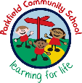
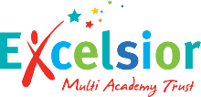
Year 3 Newsletter
Autumn Term- September 2026
Mr Lewis/ Mrs Begum 3LB
Miss Tahir 3T
Miss Bano 3B
Mrs Hussain
Homework
Spellings – Lists will be given out on Monday, to be tested on the following Monday.
Magma – This is our new maths, home learning app. Pupils will be set tasks each week, but can also undertake their own practice. We would like to aim for two tasks to be completed a week.
Times Table Rockstars – used to practice recall of times table facts.
Reading – children should be reading everyday, ideally with an adult who can help them with tricky words and ask them questions about what they have read. Children’s reading diaries will be checked daily.
Your child may receive additional homework, tailored to their learning needs. This will be discussed with you by the class teacher.

A message from your child’s teachers:
A warm welcome back to all our Year 3 parents and carers. We hope you all had a lovely summer break. We look forward to getting to know you as we work with your children this year. If you have any questions please contact the school office or your child’s class teacher at home time.

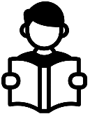
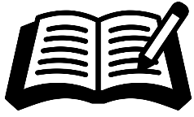
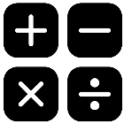
-Recognise the place value of each digit in a three-digit number
-Counting in hundreds, fifties, tens and ones plus fours and eights and comparing and ordering numbers
-Number patterns
-Addition and subtraction facts
-Adding ones, tens and hundred, with and without renaming
-Subtracting ones, tens and hundreds with and without renaming
-Using models
Important things to remember:
Writing
Reading
Maths
What we are learning this term:
Please ensure that your child comes to school every day with their own water bottle, clearly labelled with their name and class.
Our PE day is Monday.
Your child should come to school in the correct PE kit every Monday.
Children in 3LB will be attending swimming lessons every Tuesday throughout the Autumn term. (This will finish on Tuesday 15th December 2026)

Staff:
Homework:
-To form all letters correcting, using neatly, joined handwriting
-To use the full range of punctuation covered in previous years.
-To write fiction and narratives that are well structured.
-To proof read confidently and amend their own and other’s writing.

In Year 3, reading lessons are very important. You can help your child at home by listening to them read every day and asking questions to show that they have understood what they have read.


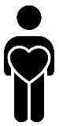




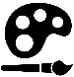

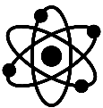
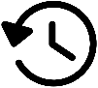

RE:
We look forward to working together with you this term!
Oracy:
Personal Development:

In Our PD lessons this term, we will be learning about relationships. We will be looking at how to share our feelings, as well as how to show respect to others and sharing our views and opinions.
Our oracy targets this term are to vary our tone of voice for humorous or sad parts of a story telling, notice when someone has not contributed and invite them to speak, take on the challenger role in a small discussion and to be able to confidently change our mind.

This term in RE we are learning about Judaism.

In music this term, we are learning how to lay the glockenspiel.

In PE, we will be focussing on fundamental skills, Outdoor Adventurous Activities and swimming.
Music:
PE:

In computing, we are going to be learning about how computers are connected.
Computing:

In art, we will be creating Gestural drawings with charcoal.
Art:

This term in the STEM lab, we will be designing and making a product using levers and linkages.
DT:

Geography is the study of places, people and their environments.
This term in geography we will be learning about Continents and Oceans.

History is the study of the past.
This term in history we will be learning about Prehistoric Britain.
.
Science is the process of learning about the natural world through observation and experimentation.
This half term we will learn about animals, including humans, and rocks and soils.
Science:
History:
Geography:

