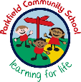
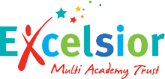
Year 6 Newsletter
Autumn Term- September 2026
A message from your child’s teachers:
We welcome you and your child to Year 6. This newsletter contains information about Year 6 and your child’s learning. If you have any questions, please speak to a member of the team.
Reading
Writing
Maths
What we are learning this term:
Miss Kaur 6HK
Mr Birch 6JB
Miss Bahia &
Mrs Sheikh 6SB
Miss Choudry 6HK & 6JB

Staff:
Homework:
Children should be reading every day at home, completed reading diaries should be brought into school every day which will be checked by the class teacher. Children will also be given CGP books & homework books, these will be given out weekly and should be brought back by Wednesday every week. New homework will be given out every Friday. We will run some SATs workshops for parents this term so you can support your child at home with their learning.

Secondary school places
The deadline to apply for a secondary school for your child is October 31st, 2026. Please visit the Birmingham City website to apply for your child’s place. Offer date is 1st March 2027.
Important things to remember:
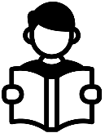
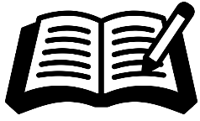
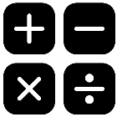

We have started this term with ‘The Graveyard book.’ This is a gripping novel which keeps the children guessing. Our focus is on developing fluency and
inference skills with a focus on developing vocabulary.
We will also look at a range of shorter extracts with a focus on reading skills such as retrieval and understanding vocabulary.

Children will start the term by writing a narrative which
includes a mysterious character. We will focus on using techniques which
create mystery within a text. In the next unit, children will write an explanation text on an extreme weather, this is linked to their geography topic.
In addition, we will teach SPAG, specifically words classes and punctuation.

In Maths, we will be covering place value and the four
Operations (addition, subtraction, multiplication and division).
Children practise their arithmetic skills daily with end of week assessments.
Children will become secure with their place value and will be able to read and write numbers to 10 million.

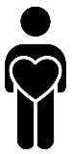

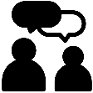


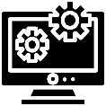


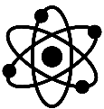
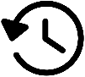

We look forward to working together with you this term!
Oracy:
Personal Development:

Our topic this term is relationships where we will look at a variety of books exploring this theme. We will look at how to challenge racism as well as how to respectively disagree with differing views.

In oracy this term we will focus on using appropriate sentence stems across the curriculum when speaking as well as using correct body language and eye contact when communicating.

This term in RE we are learning about beliefs in actions.
RE:

Our music topic this term is around singing and music appreciation with the song ‘Happy.’

In PE, we will be focussing on team sports with the aim of developing our teamwork.
Music:
PE:

In computing, we are going to be teaching children about fake news and internet safety.
Computing:

In art, we will be looking at visual literacy. We will also create our own 3D packaging.
Art:

This term in the STEM lab, we will be using CAD and textiles.
DT:

Geography is the study of places, people and their environments.
This term in geography we will be learning about extreme weather conditions through our topic ‘Extreme Earth.’

History is the study of the past.
This term in history we will be learning about propaganda where we will look at the past to determine ‘fake news.’
.
Science is the process of learning about the natural world through observation and experimentation.
This term we will learn about living things and their habitat as well as evolution and inheritance.
Science:
History:
Geography:

