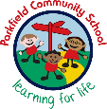
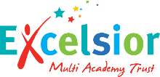
Year 6 Newsletter
Spring Term- January 2026
A message from your child’s teachers:
Welcome back to a short but busy term, we hope you have all had a wonderful break. Miss Walsh will be going on maternity leave at the start of February; we wish her all the best.
Reading
Writing
Maths
What we are learning this term:
Miss Kaur 6HK
Mr Birch 6JB
Miss Walsh 6BW
Miss Bahia 6BW
Mrs Sheikh works across all classes

Staff:
Homework:
Children should be reading every day at home, completed reading diaries should be brought into school every day which will be checked by the class teacher. This term children will be given homework which can be brought back to school in a folder. They will be given reading and maths homework this term.

Residential 29th June 2026 – 1st July 2026
There are still a few places available on our residential, the total cost is £240. If you are interested and want further information, please speak to Miss Bahia.
Important things to remember:
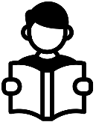
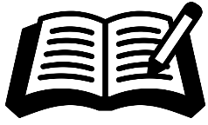
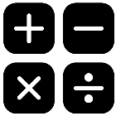

This term we will focus on analysing shorter extracts with the aim of developing retrieval and inference skills. We will work on comprehension techniques ensuring answers are precise.
Reading daily will hugely support your child’s learning, please
ensure your child is reading their home reader daily.

This term children will write a range of pieces starting with a narrative called Metamorphosis where the main character changes into an animal. Later in the term, they will write a non-fiction piece around the book, ‘The Lost Book of Adventure’ moving onto a persuasive leaflet. They will practise the skills needed as a Year 6 writers having their audience and purpose in mind.

Children will use their knowledge of maths to answer problem solving questions.
They will continue to practise their arithmetic skills daily with end of week assessments.
We will also look at measures, statistics and fractions, decimals and percentages.

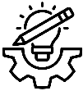
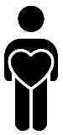

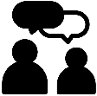


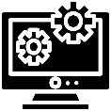
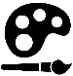
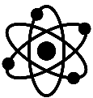
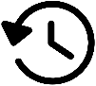


Programming: variables in games.

This term in the STEM lab, we will be looking at pulleys and gears.

In art unit this term is around activism. Children will explore how artists use their skills to speak on behalf of communities.
We look forward to working together with you this term!
Oracy:
Personal Development:

Living in the wider world – children will look at challenging prejudice as well developing critical thinking skills when looking at media.

In oracy this term we will focus on using appropriate sentence stems across the curriculum when speaking as well as using correct body language and eye contact when communicating.

In RE children will explore alternative beliefs.
RE:

Listening and appreciating music as well as identifying pulse and beat.

In PE, children will be learning practising yoga and gymnastics.
Music:
PE:
Computing:
Art:
DT:

Geography is the study of places, people and their environments.
This term in geography we will be learning about population

History is the study of the past.
This term our unit is around the Windrush generation.
.
Science is the process of learning about the natural world through observation and experimentation.
Our unit this term is around electricity: investigating circuits and switches
Science:
History:
Geography:

