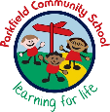
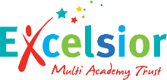
Year 2 Newsletter
Autumn Term- September 2026
A message from your child’s teachers:
We welcome you and your child to Year 2 and we hope that you had a restful break. This newsletter contains information about Year 2 and your child’s learning. If you have any questions, we are here to help.
Reading
Writing
Maths
What we are learning this term:

Mrs Jukes
Mrs Iqbal
Mrs Bibi
Mrs Najib
Mrs Cornforth
Mrs Drysdale

Staff:
Reading - Every child will bring home a school, reading book. Children should be reading every day at home, ideally with an adult who can help them with the tricky words and ask them questions about what they have read. Reading diaries should be brought into school every day. We ask parents to sign the reading diary every evening after you have heard your child read.
Magma Maths – this is our new home learning app for pupils to complete tasks and practise their maths skills. We aim for pupils to complete two tasks a week.
Times Table Rock Stars/ Numbots – these are our two other maths app, which we use to help promote times table fluency and recall of key number facts.

Homework:
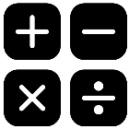
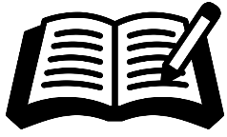
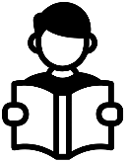

In Year 2, some pupils will continue with phonics lessons. You can help your child at home by practising the sounds that they have focussed on in the week.
One class will be reading a variety of fiction, non-fiction and poetry texts. Their learning will focus on building fluency and practising key skills such as understanding vocabulary, retrieval and inferencing. Each Friday, pupils will bring home the text they have been working on in class along with their reading book, so they can share their learning and practise their skills at home.

- To write using the correct letter formation and begin to use joined handwriting.
-To use capital letters and full stops and other punctuation such as question marks and exclamation marks accurately.
- To develop composition by planning and writing short pieces of writing, such as stories, descriptions and simple reports.
-To retell and write stories with a beginning, middle and end.
- To use the conjunctions: and, but, so and because, to vary sentences.
- To sound out words using their phonic knowledge.

- Read and write numbers to at least 100 in numerals and in words.
- Recognise the place value of each digit in a two-digit number (tens, ones).
- Compare and order numbers from 0 up to 100; use <, > and = signs.
- Solve problems with addition and subtraction.
- Recall and use addition and subtraction facts to 20 fluently, and derive and use related facts up to 100.
Important things to remember:
Please ensure that your child comes to school every day with their own water bottle, clearly labelled with their name and class.
Our PE day is Wednesday. Your child should come to school in their PE kit every Wednesday.
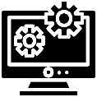
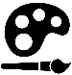
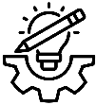
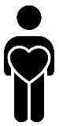

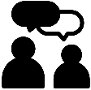
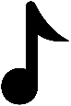

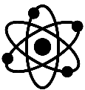
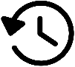
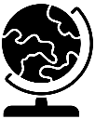

Our oracy targets this term are to use non-verbal signals to show if we agree, disagree, or want to build on others’ ideas and to speak confidently in small group discussions.

In Our PD lessons this term, we will be learning about relationships. We will explore different types of behaviour, understand what makes a good friend, learn how to share views and opinions respectfully and recognise that everyone belongs and should feel accepted. .

This term in the STEM lab, we will be designing and making a healthy pizza.

In art, we will explore different materials and techniques, inspired by a range of artists to develop creativity and express ideas.

In computing, we are going to be learning about what information technology (IT) is and how it can help us in school and beyond in everyday life.
DT:
Art:
Computing:
We look forward to working together with you this term!
Oracy:
Personal Development:

This term in RE we are learning about Buddhism.
RE:

Our music topic this term is called Hands, Feet, Heart! Look out for some excellent singing!

In PE, we will be focussing on invasion games, team building and ball skills.
Music:
PE:

Geography is the study of places, people and their environments.
This term in geography we will be learning about the geographical features of the seaside.

History is the study of the past.
This term in history we will be learning about the Great Fire of London.
.
Science is the process of learning about the natural world through observation and experimentation.
This half term we will learn about different animals, including humans.
Science:
History:
Geography:

