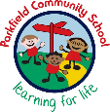
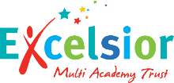
Year 2 Newsletter
Spring Term- January 2026
A message from your child’s teachers:
Happy New Year! We hope you had a lovely break. It’s been wonderful to see how well the children have settled in, and we are proud of their positive attitudes to learning. This newsletter shares key information for the Spring term. If you have any questions, we are here to help.
Reading
Writing
Maths
What we are learning this term:

Mrs Jukes and Miss Dean
Mrs Begum and Mrs Iqbal
Miss Robinson
Mrs Cornforth
Mrs Drysdale
Mrs Najib
Staff:
Important things to remember:
Please ensure that your child comes to school every day with their own water bottle, clearly labelled with their name and class.
Our PE day is Wednesday and Thursday. Your child should come to school in their PE kit every Wednesday and Thursday.
Homework:
Reading - Every child will bring home a school, reading book. Children should be reading every day at home, ideally with an adult who can help them with the tricky words and ask them questions about what they have read. Reading diaries should be brought into school every day. We ask parents to sign the reading diary every evening after you have heard your child read. Mathletics - children will be expected to earn 1000 points a week on Mathletics. They should log on for around 20 minutes, three times a week

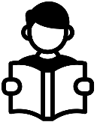
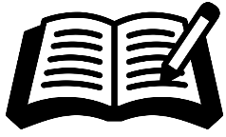
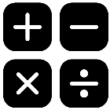

- Fiction: Writing a narrative dilemma based on the traditional tale Hansel and Gretel. Writing an exciting adventure story based on the narrative The Pirates Next Door.
- Non-Fiction: Writing a diary entry recounting events and feelings of Scott of the Antarctic.
- To develop composition by planning and writing short pieces of writing, such as stories, descriptions and simple reports.
-To use the present and past tenses correctly with a focus of irregular verbs.
- To use the conjunctions: and, but, so and because, to vary sentences.

- Recognise and use symbols for pounds (£) and pence (p), combine amounts to make a value, and find different ways to make the same amount.
- Compare, describe and solve practical problems involving mass (heavier, lighter, equal).
- Recognise, find, name and write fractions (¹/₂, ¹/₄, ²/₄, ³/₄) of shapes, quantities and numbers.
- Interpret and construct pictograms, tally charts and block diagrams, and ask and answer questions about the data.
- Word Problems – Solve one-step and two-step problems.

Measurement: Money – Solve simple problems involving giving change and comparing amounts of money.

In Year 2, some pupils will continue with phonics lessons. You can help your child at home by practising the sounds that they have focussed on in the week.
One class will be reading a variety of fiction, non-fiction and poetry texts. Their learning will focus on building fluency and practising key skills such as understanding vocabulary, retrieval and inferencing. Each Friday, pupils will bring home the text they have been working on in class along with their reading book, so they can share their learning and practise their skills at home.

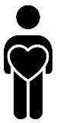
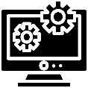
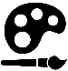




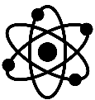
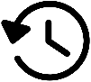


In computing, we will be learning about programming by designing robot algorithms. We will also learn how to collect, organise and present data and information using pictograms.
DT:

This term in the STEM lab, we will explore textiles, focusing on templating and joining techniques through a design challenge to create a coat for Scott of the Antarctic.

Our oracy targets this term are to develop confident speaking skills by using appropriate posture, tone and volume. We will practise retelling events calmly and in a logical order, while also using taught vocabulary independently.
Oracy:

In our PD lessons this term, we will be learning about living in the wider world. We will explore what makes us unique, the groups and communities we belong to and the special people in the community who help us. We will also focus on staying safe, saving energy and caring for our local environment.
Personal Development:
Computing:
Art:

In art, we will explore colour mixing and mark making to create expressive paintings. We will also study brushwork of famous artists, applying these techniques to their own learning.
We look forward to continuing to work together with you this term!

This term in RE we are learning about Sikhism.
RE:

Our music topic this term is called Zoo time. Look out for some excellent singing!

In PE, we will be focussing on invasion games, fundamentals, gymnastics, yoga and dance.
Music:
PE:

Geography is the study of places, people and their environments.
This term, we will use maps to locate the journey taken by Robert Falcon Scott to Antarctica.

History is the study of the past.
This term in history we will be learning about Scott of the Antarctic and the Titanic.
.
Science is the process of learning about the natural world through observation and experimentation.
This half term we will learn about the uses of everyday materials.
Science:
History:
Geography:

