Rapid lateral flow testing for households and bubbles of school pupils and staff

About 1 in 3 people with coronavirus do not have symptoms but can still pass it on to others. Regular testing of people without symptoms is important to help stop the virus spreading and protect your loved ones. As lockdown restrictions gradually ease we all need to play our part to help protect each other.
The most important symptoms of COVID-19 are recent onset of any of the following:
- a new continuous cough
- a high temperature
- a loss of, or change in, your normal sense of taste or smell (anosmia)
If you have symptoms of COVID-19, arrange to have a PCR test if you have not already had one. Stay at home while you are waiting for a home self-sampling kit, a test site appointment or a test result. Do not use the rapid lateral flow testing service as this is only for people without symptoms.
Order a test for people with symptoms online or call 119.

How to get a rapid lateral flow test
There are different ways to get a test for school staff, pupils, and members of their households, childcare and support bubbles in England who do not have symptoms of coronavirus.
- first 3 tests at their place of study under the supervision of a trained operator
- fourth test themselves using a home test kit
Pupils will then continue taking twice-weekly tests using a home test
Members of households, childcare or support bubbles of school staff and pupils
This section does not apply to secondary school pupils, and primary and secondary school staff, who should take twice-weekly tests using home test kits provided by their school.
From 1 March 2021, if you’re a member of a household, childcare bubble or support bubble of staff or a pupil you can get a twice-weekly test:
- through your employer if they offer testing to employees
- at a local test site
- by collecting a home test kit from a test site
- by ordering a home test kit online

Get a test through your employer
Your workplace may offer rapid lateral flow testing to you. Contact your employer to find out more.
Take a test at a rapid lateral flow test site
You can take a rapid lateral flow test at a local site. Testing at these sites is assisted, which means you will swab yourself under the supervision of a trained operator.
You may need to book an appointment.
Find rapid lateral flow tests sites here.

Mobile test centres currently open:

Blakesley Hall, Blakesley Road B25 8RN
The Lighthouse, 100 Alma Way, Aston B19 2LN
Heartlands Resource Centre, 6 Inkerman Street B7 4SB

Some Community Pharmacies also offer twice weekly rapid lateral flow testing, the closest of these to Parkfield Community School are:

Richyal Pharmacy, 229-231 Alum Rock Road B8 3BH
Hingley Phramacy, 185 Alum Rock Road, B8 1NJ
Pal Chemist, 508 Alum Rock Road B8 2HX

Collect test kits
You can collect 2 packs of home test kits at a local collection point. See the nearest centres below to Parkfield Community School. Each pack contains 7 tests.
Anyone 18 or over can collect. You can check online if the location is busy before you go.
Find your nearest home test kit collection point.

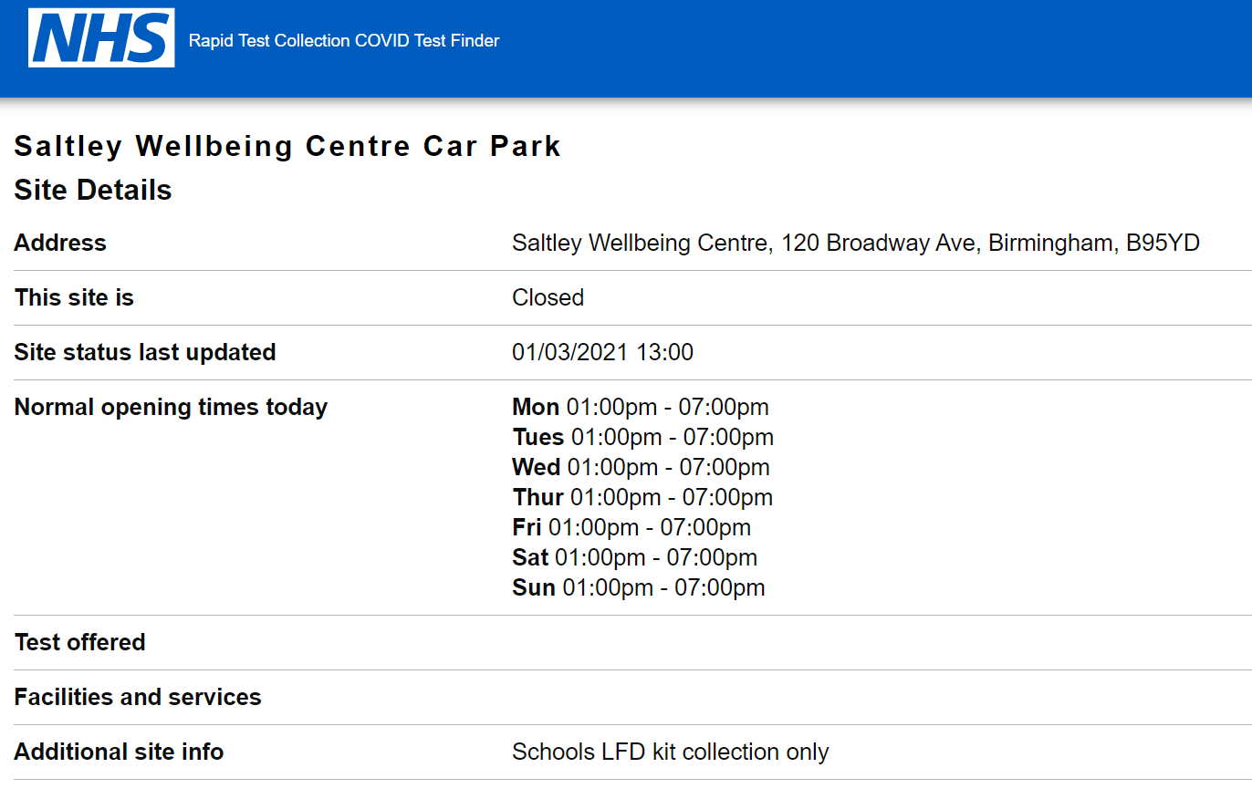

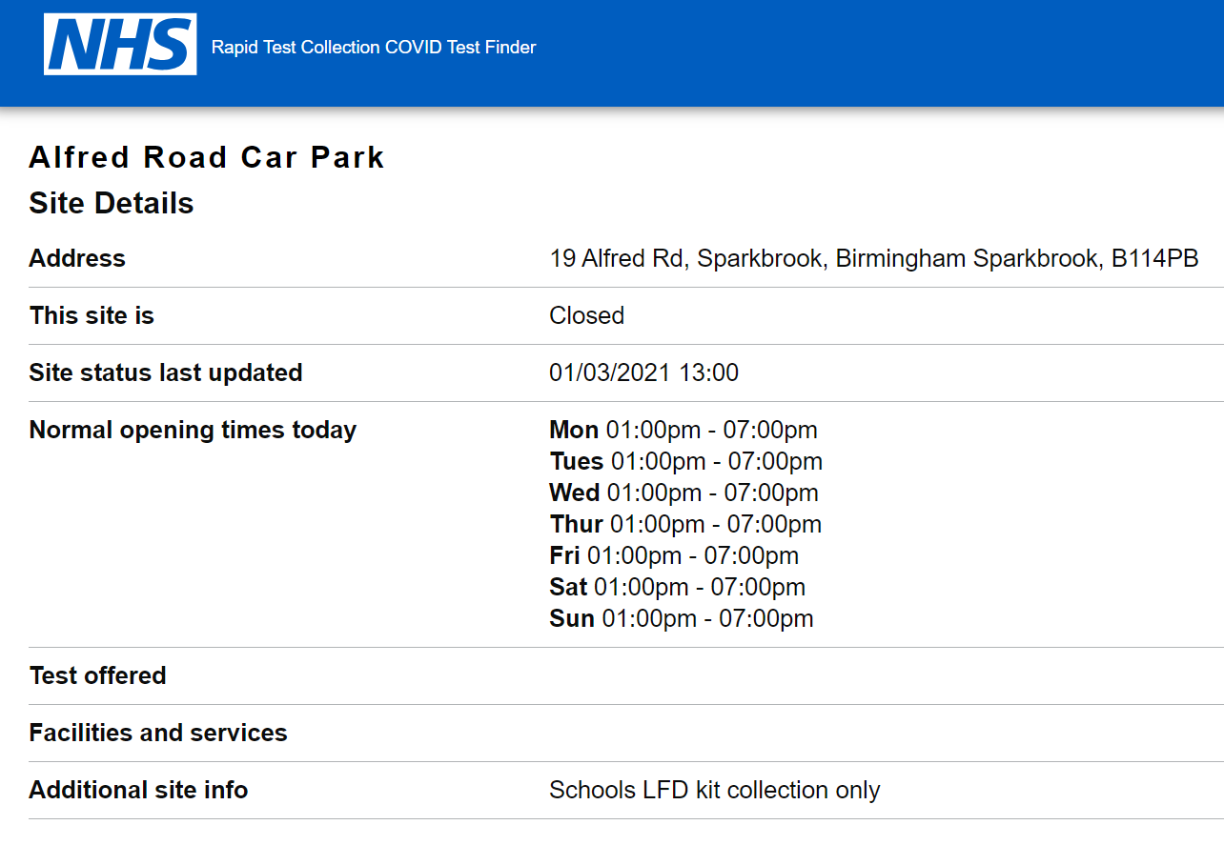
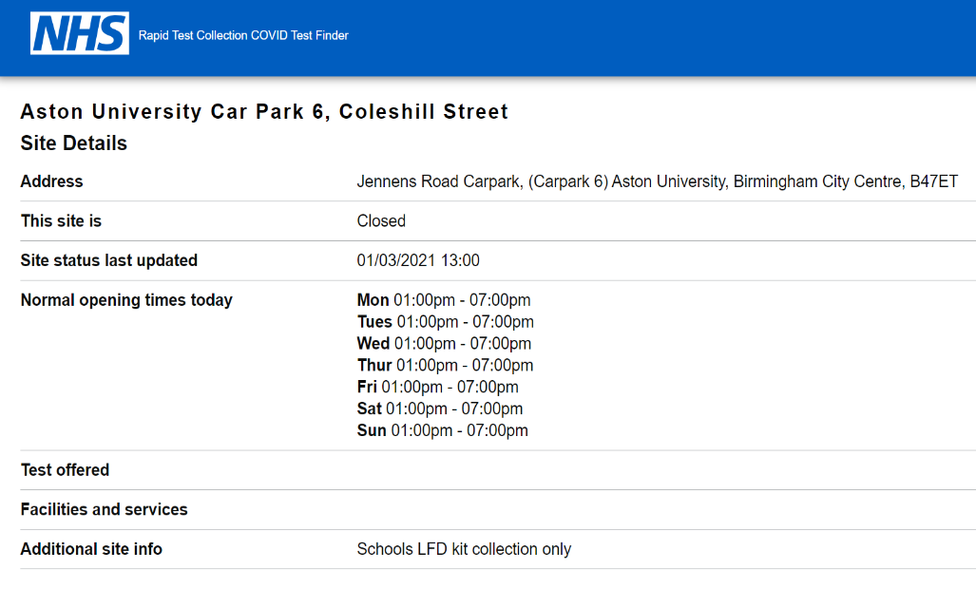

Order home test kits online
If you cannot get tested at your workplace or are unable to go to a test site or collect test kits, you can order a home test kit online.
Do not order online if you can get a test through other methods. This frees up home delivery for those who need it most.
Order rapid lateral flow home test kits
What twice-weekly testing involves
You will be asked to:
- take a test twice a week (every 3 or 4 days apart)
- report every result to NHS Test and Trace on the same day you take the test
Report your test result online or by calling 119.
If anyone tests positive or gets coronavirus symptoms, they should tell the school and:
- self-isolate immediately
- get a PCR test to confirm the result
- follow the stay at home guidance for households with possible coronavirus infection

A negative result means the test did not find signs of coronavirus. But this does not guarantee you do not have coronavirus, so you should keep following all coronavirus advice including:
- regular handwashing
- social distancing
- wearing a face covering where recommended

