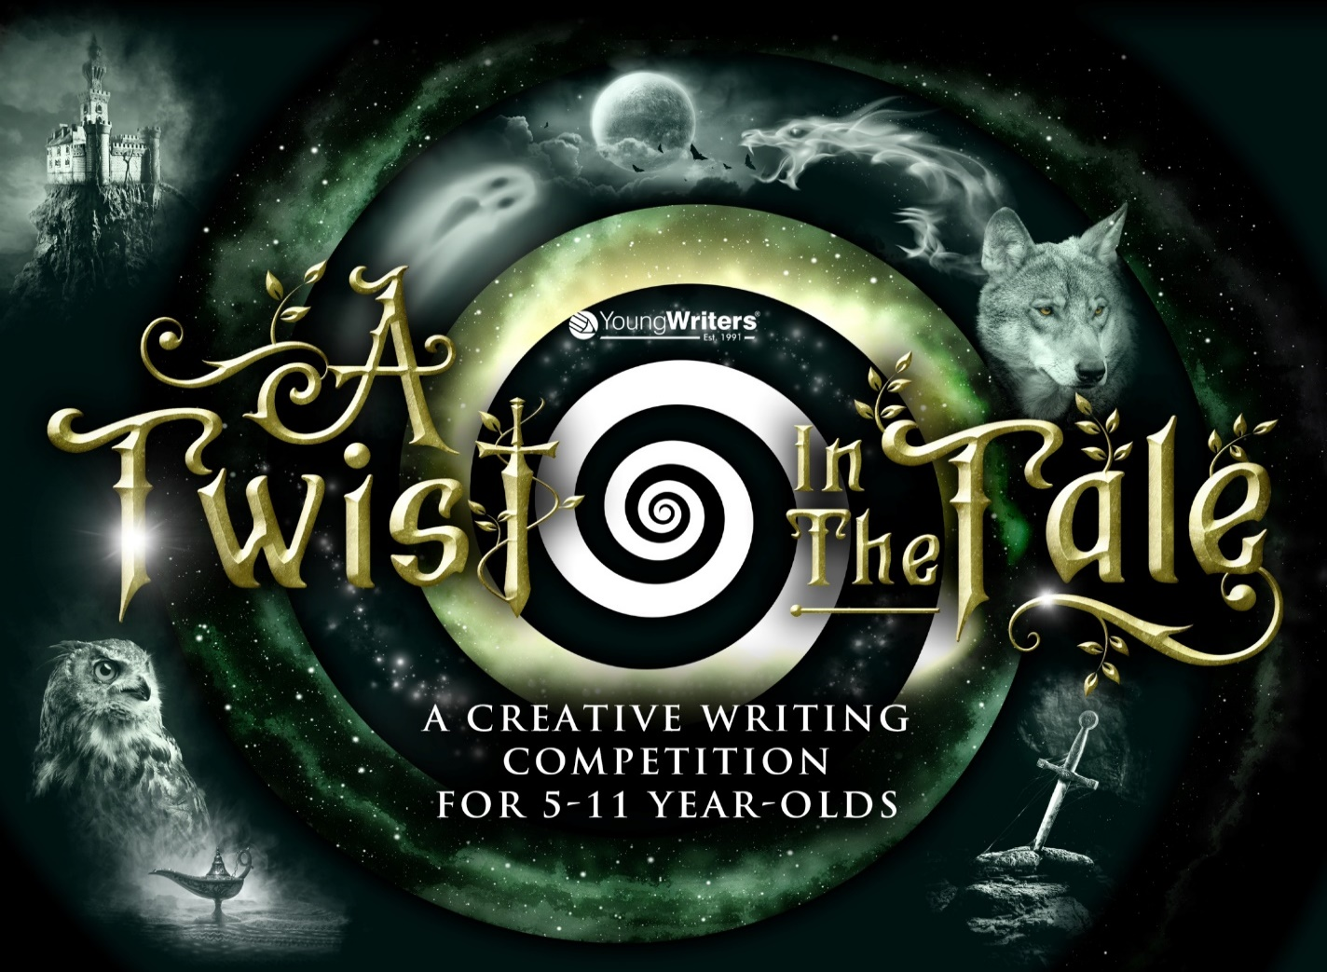

Have you ever thought that there was more to the story than the author was telling? Did you ever think that maybe the story happened differently to the way we’ve been told?

Here’s your chance to set the story straight with **A twist in the tale writing competition.** This writing competition is a challenge to retell a familiar story or a historical event with an awesome twist!

* Maybe the story/event took place in a different place or time?
* Maybe the story/event is told from a different character’s point of view?
* Maybe there is a twist in the main event of the story/event?
* Maybe the story/event ended differently to how we assumed?

Make the tale your own. Be creative and original. Your tale should not be very similar to an existing story/historical event. The twist in your tale should be a big change and not just a little change.

**As a challenge, can you write your tale in 100 words or less?**

Please submit your writing via the form on the school website:

<https://forms.office.com/r/e9p1qVziZa>

or via Google classroom

<https://docs.google.com/forms/d/e/1FAIpQLSd5Xl9ufJasBVeW-uSWffsYTUhxy2l62CM8i1dxOyiOxtyHtw/viewform>

by **Friday 25th November, 2022.**

Or, you can hand your written work to me, Miss Matin, in the library.   
Best of luck!