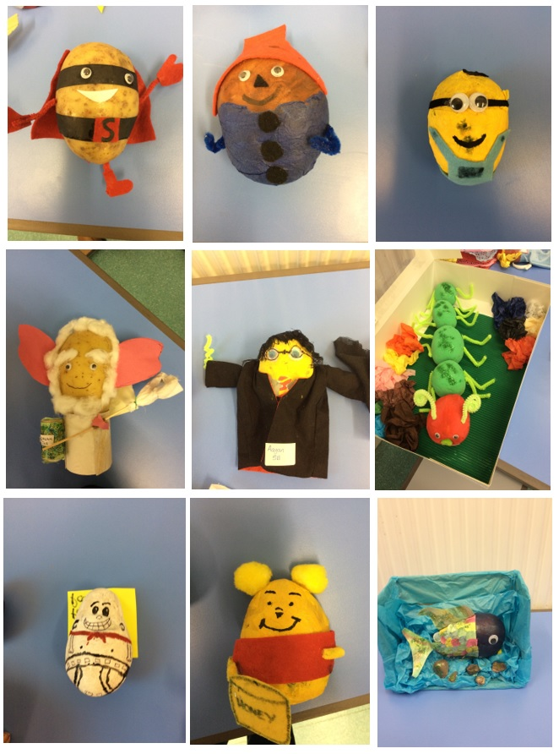

Next Thursday, the 4th March is World Book Day and to celebrate, we are inviting you to decorate a potato as your favourite story book character.  
There will be potatoes available for collection from school from Monday 1st March, 9am but the number is limited so please collect early to avoid disappointment.

The best decorated potatoes will be judged the winners! Have fun and good luck!

