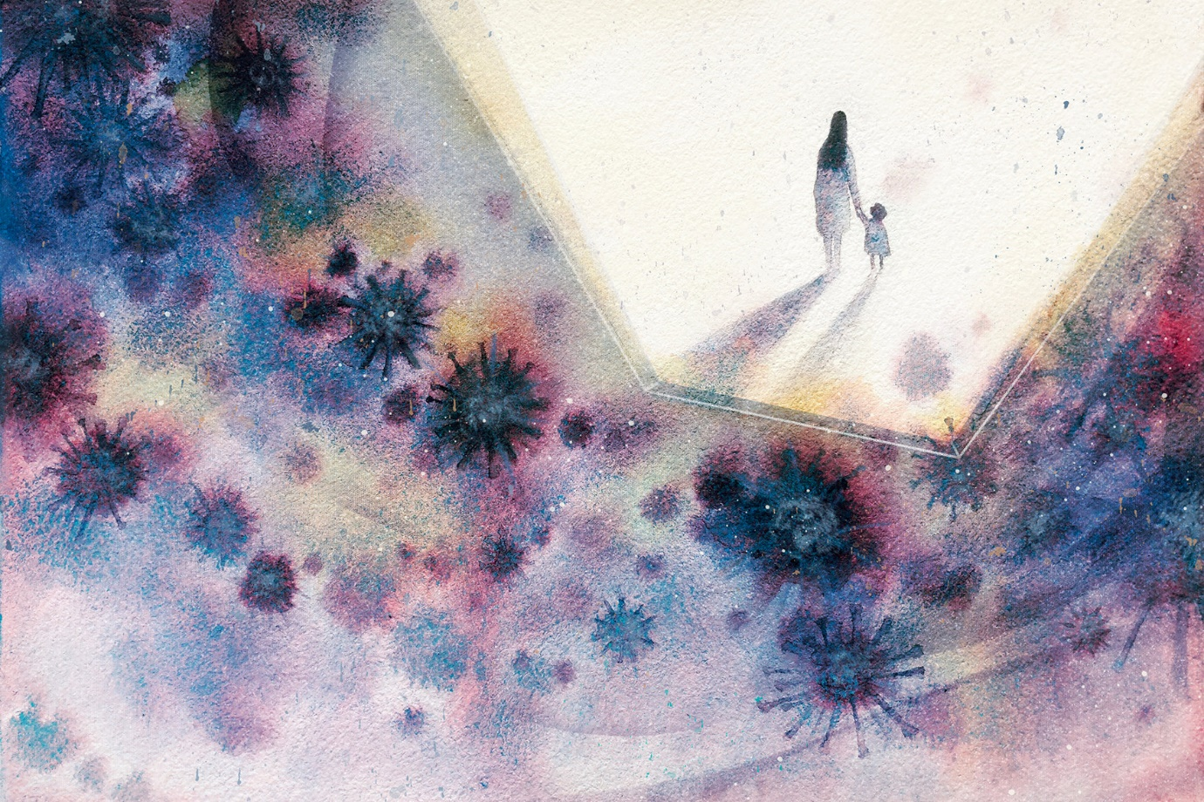

What a year (or two!) it’s been…

I am delighted to announce the launch of a new writing competition open to every child in the school! The theme is anything and everything to do with the pandemic. The writing can be a poem, a piece of non-fiction or any genre of fiction.

Think about the following:

* Did you enjoy spending time at home during lockdown or did you miss your friends?
* Did you get on well with remote learning or did you miss your lessons at school?
* Were you worried about anything and what made you stop feeling worried?
* How did you feel about using technology more, for school and talking to your relatives?
* Did people help and support each other or did people think about themselves?
* What else do you think was positive or negative about the situation?

**The deadline is Friday 25th June, 12pm**

You may submit entries by filling in the form accessed via the school website.

You can also enter by filling in the quiz form on Google Classrooms

<https://docs.google.com/forms/d/e/1FAIpQLSdhqwDuUomSZ72pJsxneDaoaLeTaFwM8P8Xsx8rDyhWH0LDAw/viewform>

There will be winners from each year group as well as an overall winner for the whole school. I look forward to reading all of your entries! Good luck!